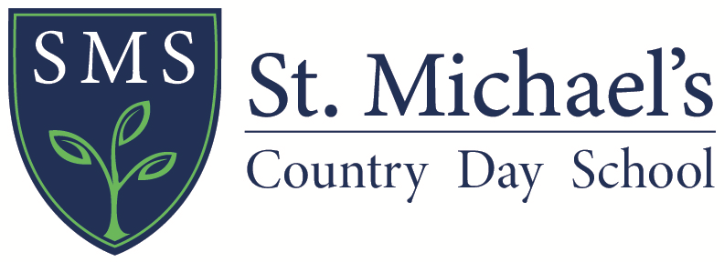

REQUEST FOR RECORDS AUTHORIZATION

_________________________________________________________________________________________________
Student Name Grade Completed in June

Important Note to Parents:

Please complete this form and submit it to your child’s previous school as soon as possible. This will allow St. Michael’s Country Day School to have your child’s academic and health records.

I consent to the release of my child’s records to

St. Michael’s Country Day School

Signature of Parent or Guardian Date

To School Registrar:

The above named student has enrolled at St. Michael’s Country Day School for the 2020-2021 school year. Please submit the applicant’s complete health record and academic information, including standardized test results, attendance records, and any psychological evaluations or individualized education plans.

This material should be mailed to:

St. Michael’s Country Day School
Admission Office
180 Rhode Island Ave.
Newport, RI 02840

We appreciate receipt of this material as soon as possible.
If you have any questions, please contact the Admission Office at 401-849-5970 x302.
Thank you for your assistance.

